SAHARA ROOFING TECHNO SOLUTION

ENGINEERS & CONTRACTORS

ADDRESS:-
SHOP NO. 03, FIRST FLOOR, G - BUILDING,
MOUNT VIEW RESIDENCY, VASARANG ROAD,
KHOPOLI – 410 203 TAL. KHALAPUR, DIST. RAIGAD
CELL: 96732 31924/ 94210 11777
www.sahararoofing.in
santoshkangale.sk@gmail.com
santosh@sahararoofing.in

SAHARA ROOFING TECHNO SOLUTION
Engineers & contractors

Shop no. 03, First floor, G-building, Mountview Residency, Vasarang road, Khopoli – 410203
Tal. Khalapur, Dist. Raigad
Email: - santoshkangale.sk@gmail.com, santosh@sahararoofing.in Mobile:-09673231924

Subject: INTRODUCTION

Dear Sir,

We, SAHARA ROOFING TECHNO SOLUTION, have great pleasure in introducing ourselves as one of the reputed construction company.

We have proven experience & time bound completion track record and undertaken works such as fabrication and erection, testing and commissioning of piping of various system, Plant, tanks, vessels and erection of static / rotary equipments. Machinery, fabrication and erection of structural steel works as well as color coated, A.C., G.C. sheet fixing Work And Technical Manpower Supply for All fabrication and Maintenance related Jobs.

We are enclosing herewith our company profile for your kind perusal, which will reveal details and activities undertaken by our organization in the field of heavy industries project, steel, power sector etc.

We hope you will consider us as per your requirements & register our firm & provide opportunity to serve your good self.

Thanking You,

Yours Truly,
For SAHARA ROOFING TECHNO SOLUTION,

Santosh Kangale

SAHARA ROOFING TECHNO SOLUTION
CONTENTS

ANNEXURE A - FIRM’S STATUS
ANNEXURE B - WORKING STRENGTH
ANNEXURE C - PAST EXPERIENCE
ANEXURE D - LIST OF EQUIPMENT -
MACHINERY AND TOOLS & TACKLES

SAHARA ROOFING TECHNO SOLUTION
ANNEXURE -A
Company Name | Sahara roofing techno Solution
RESPONSIBLE PERSON | SANTOSH KANGALE
COMPANY ADRESS | SHOP NO-3, FIRST FLOOR, G BUILDING, MOUNTAIN VIEW, VASRANG ROAD, KHOPOLI-410203
COMPANY PHONE NO | 9673231924/9421101777/8668964672
EMAIL | santoshkanagle.sk@gmail.com
WEBSITE | www.sahararoofing.com
GST NO. | 27BJGPK466N1ZM
PF NO. | THVSH1285297
ESIC | 34000361430000999
PT NO. | 27285296964P
WELFAR NO. | 27285296964P
UDYOG AADHAR | MH 27B0004024
SHOP ACT LICN | 1910300313310061
PAN NO | BJGPK4664N

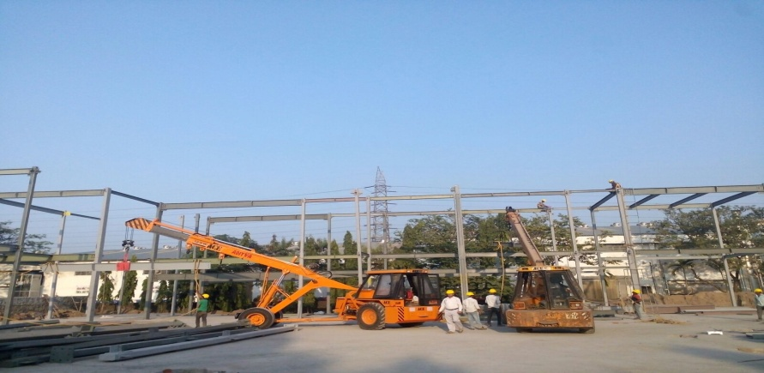
ANNEXURE-B

STRENGTH
1 | MANAGER | 01
2 | MECHANICAL ENGINEER(BE) | 01
3 | ACCOUNTANT | 01
4 | RIGGER FOREMAN | 05
5 | FITTER | 10
6 | PIPE FABRICATOR | 05
7 | PIPE /MAINTENANCE FITTER | 02
8 | STRUCTURAL FABRICATOR | 05
9 | STRUCTURAL FITTER | 05
10 | TIG WELDER | 10
11 | ARC WELDER | 10
12 | I B R WELDER | 10
13 | GAS CUTTER | 05
14 | GRINDER | 05
15 | HELPER | 10
16 | ITI FITTER | 12
17 | ITI FITTER | 12

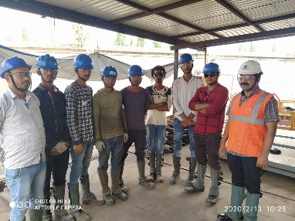

ANNEXURE-C

Name of the clients | Description of job | Duration | Year of completion
LARSEN &TOUBRO LIMITED, CONSTRUCTION. | Dowell Bar Cutting & Painting Work | 25- Aug -2018 | Till Date
TATA STEEL BSL LTD. | All Type fabrication Erection Maintenance technical Man Power Supply Sheeting Work | 2018 to Till Date | Till Date
TATA STEEL BSL LTD.  Chakan-Plant | All Type fabrication Erection Maintenance technical Man Power Supply Sheeting Work | 2018 to Till Date | Till Date
TEJ CONTROL SYSTEM PVT.LTD | Motor Mounting & Fixing In Fabrication | 18- JULY-2019 | 02-jan-20
DHIM | Mechanical Commissions work And Technical Man power Supply | 26-Feb-2019 | 30-june-19
UTTAM GALVA  STEELS LTD. | All Types of Sheeting roofing work And All Type of Fabrication & Erection work. | From 2006 | Till Date
JSW -MI STEEL SERVICE | Rail erection and Alingnment work for Transfer Trolly | June 2015 | 05-jan-2016

TEXTURING TCHONLOGY PVT.LTD | Roll Stand Block Fabrication  Air pipe line Fabrication | 20- Nov-2019 | Till Date
BHUSHAN  STEEL PVT LTD | ALL Type of Mechanical Shutdown & Bre  takedown work And fabrication and Erection work of Safety Maintenance. | 20 –Sep -2019 | Till Date
POSCO MAHARASHTRA STEEL | Reworking of Steel Sleeve  Steel Sleeve 610mm ID | 20 –Sep -2019 | 05-Nov-19
Gopani metal industries Pvt Ltd | All Type fabrication Erection Maintenance technical Man Power Supply Sheeting Work | 10-jan-2021 | 1-4-2021
Taloja steel pvt ltd | All Type fabrication Erection Maintenance technical Man Power Supply Sheeting Work | 10-jan-2021 | 1-4-2021
Topwoth Mega -pipes Pvt ltd | All Type fabrication Erection Maintenance technical Man Power Supply Sheeting Work | 15-jun-2021 | Till date

Letter Head Sample

SAHARA ROOFING TECHNO SOLUTION
FABRICATION & MAINTANCE
FABRICATION: STUCTURE, PIPE LINE, SLEEVE ID OD, PEP FABRICATION
ERECTION: STUCTURE, MACHINE, ALL TYPE MAINTANCE
SHEETING: COLOUR COATED, TECHNICAL MANPOWER SUPPLIERS.
Santoshkangale.sk@gmail.com/santosh@sahararoofing.in 9673231924/8668964672

Sahara roofing techno solutions
ANNEXURE -D
Sr. no | Type Of Machine | Age of M/C | Qty | Make of Machine | Specification
1 | Welding Rectifier | 2 years | 03 | 1 Memco  2 Jet Arc
2 | Welding Transformer | 4 years | 10 | Jet Arc
3 | Welding Generator | 3years | 02 | Advani
4 | Drill Machine Pillar Type | 2 Years | 02
5 | Magnetic Drill M/C. | 2 Years | 02
6 | Grinding m/c. | 2 Years | 10 | 1 Wolf  2 Black& Decker | GQ-4,AG-7,FF-2
7 | Bending m/C | 4 years | 02
8 | Pipe & Cutting torch | 2 Months | 10
9 | Argon & Cutting torch | 2 Years | 15
10 | Chain pully Block | 3 Years | 06 |  | 1.5 Ton (2 NOS)
11 | Dowell Bar Cutting Machine | 2 Years | 02 |  | 2.5 Ton (2 NOS)
12 | Tie Bar Steel Cutting Machine | 2 Years | 02 |  | 3.2 Ton (1 No.)
12 | Pug machine | 2 Years | 04

SAHARA ROOFING TECHNO SOLUTION
ORGANIZATION CHART

MANAGING DIRECTOR

ASST.
[MANAGER]

[SITE MANAGER]

[ADMIN-ACCOUNTANT]

[supervisor]

WORKERS

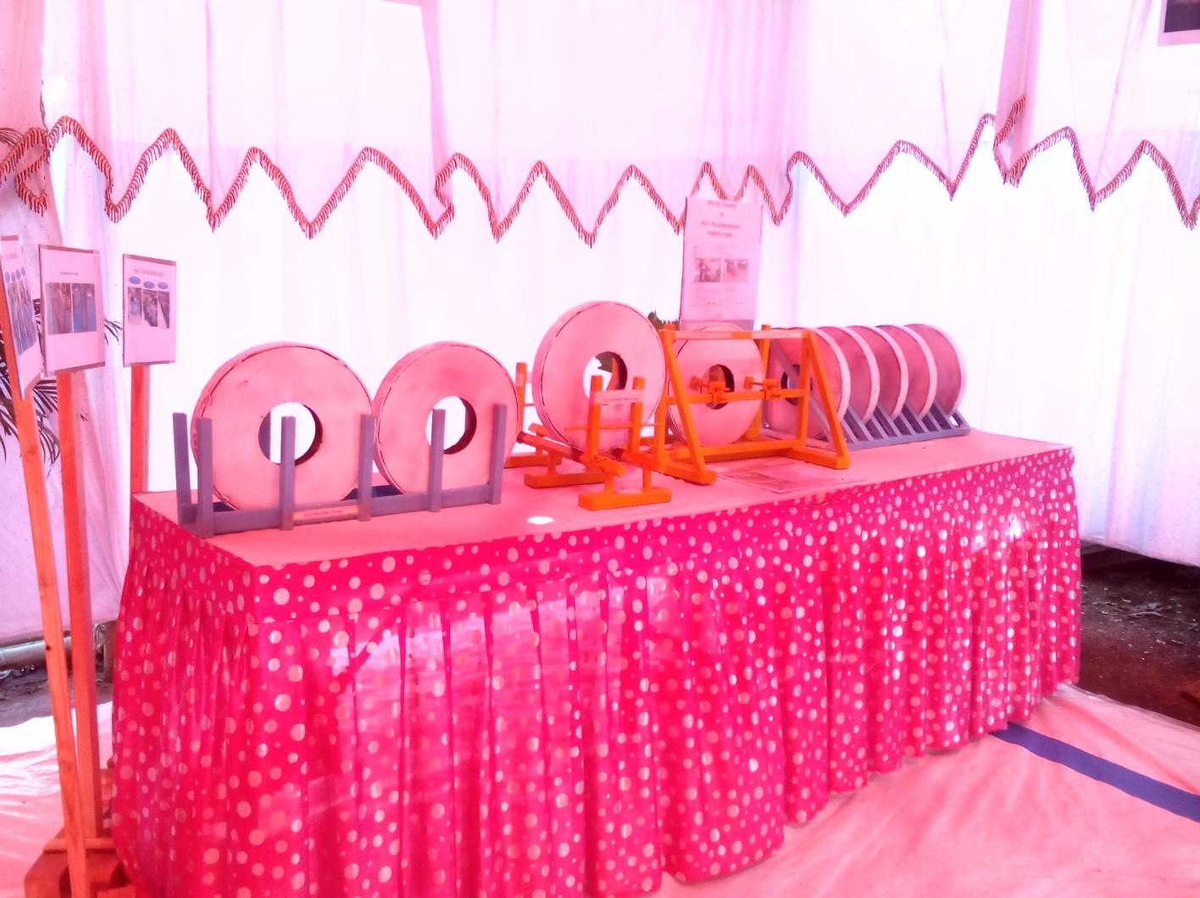
01. Slit Coil Stacking Packing Stand Fabrication Work
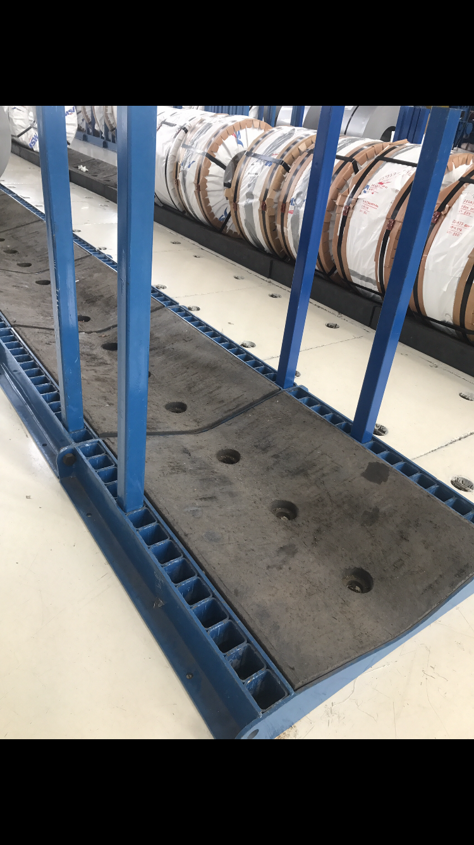
02. Slit Coil Stand

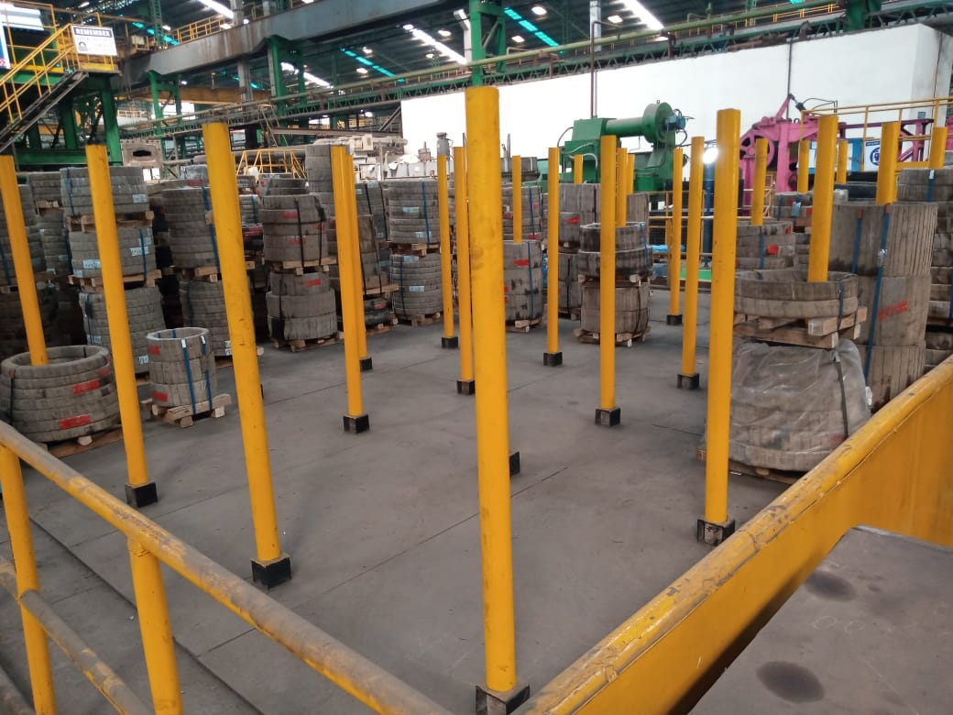
03 SLIT COIL STORAGE STAND
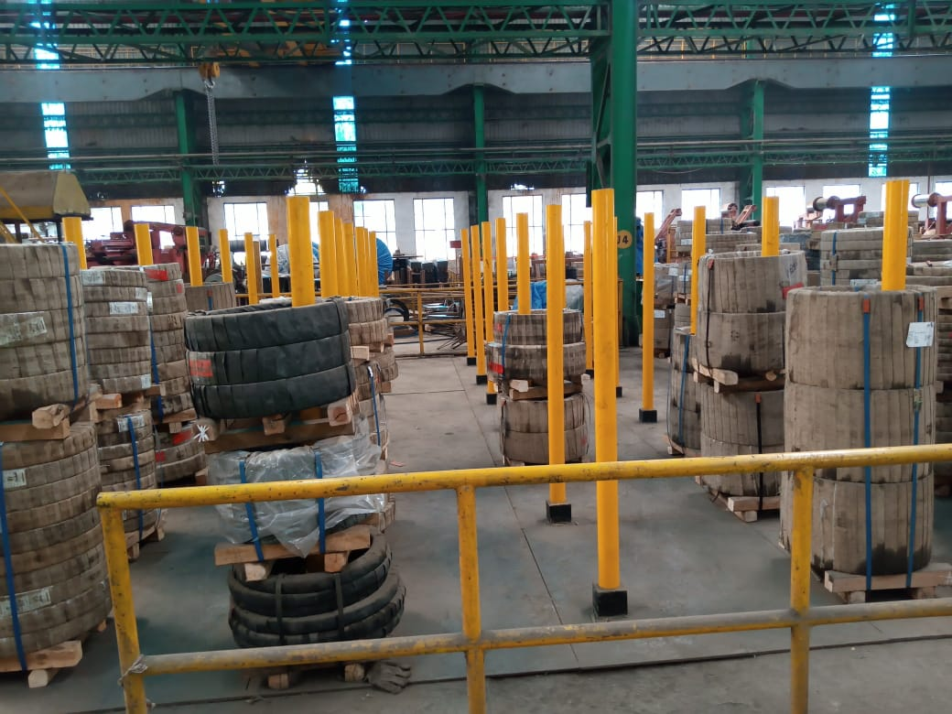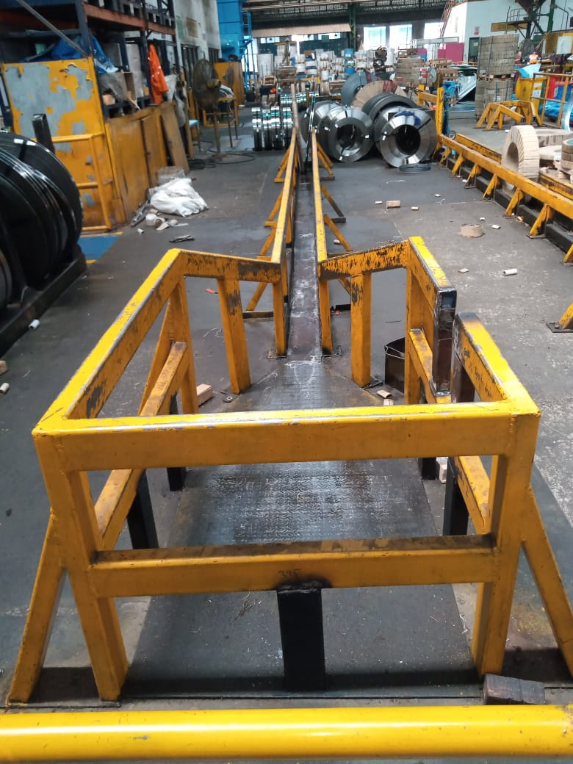

04 SLIT COIL STORAGE STAND 05 CR SLIT COIL PACKING STAN

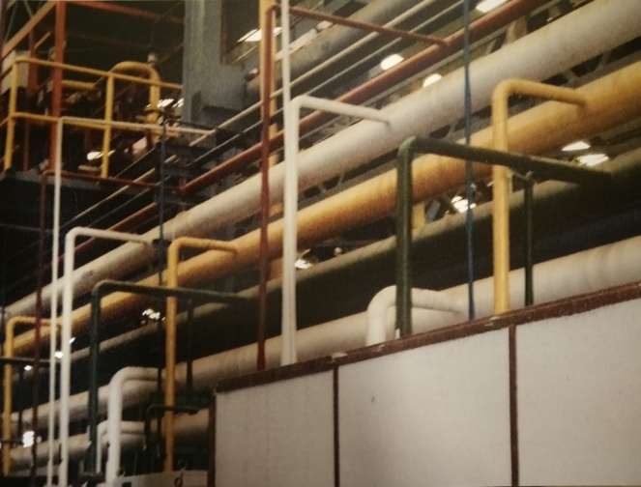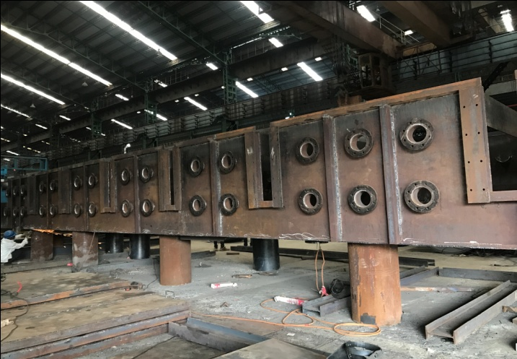
06 Pipe Line Fabrication & Erection Work 07 PICKLING LINE ACID TANK FAB-
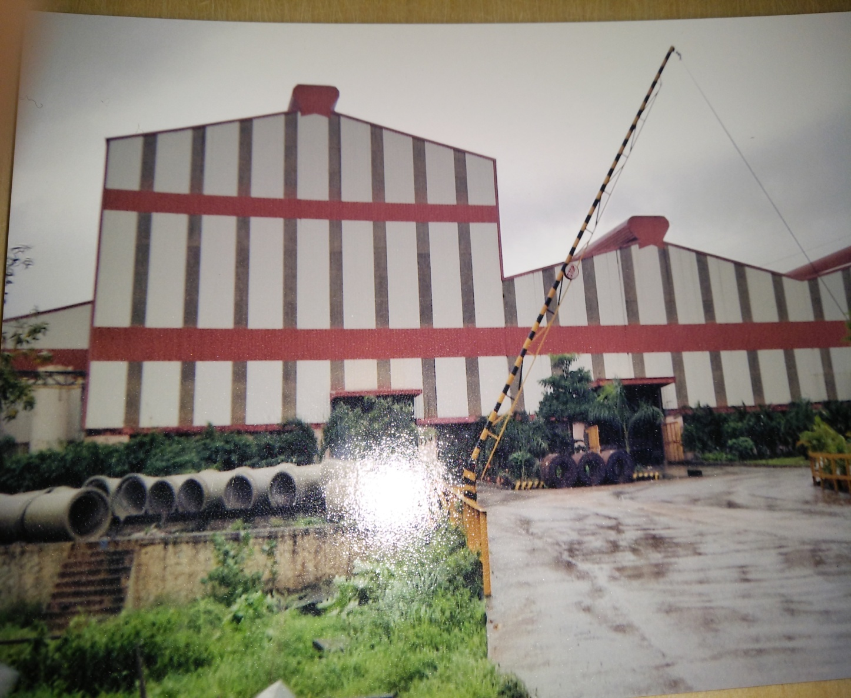
08 profile sheet fixing work

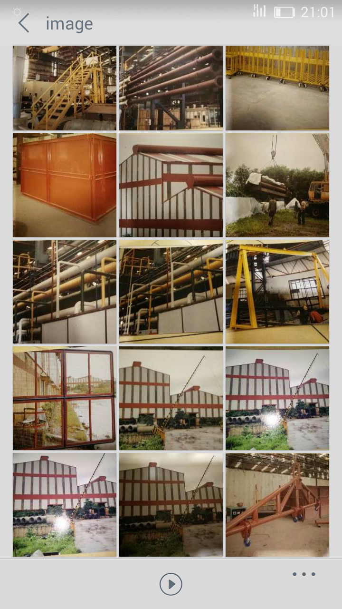
09 project Utility Fabrication Work

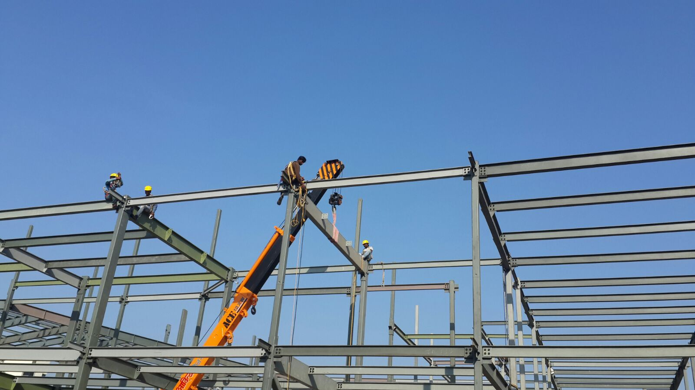
10 Bajaj Electrical RND Centre project Fabrication Work
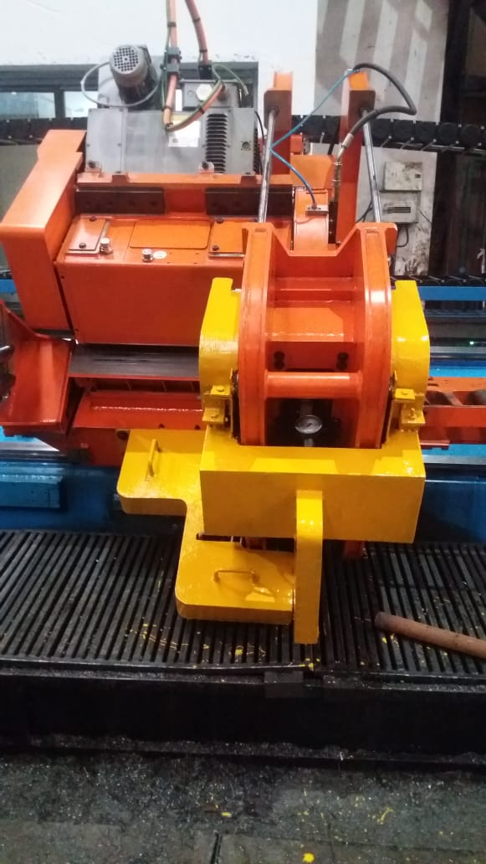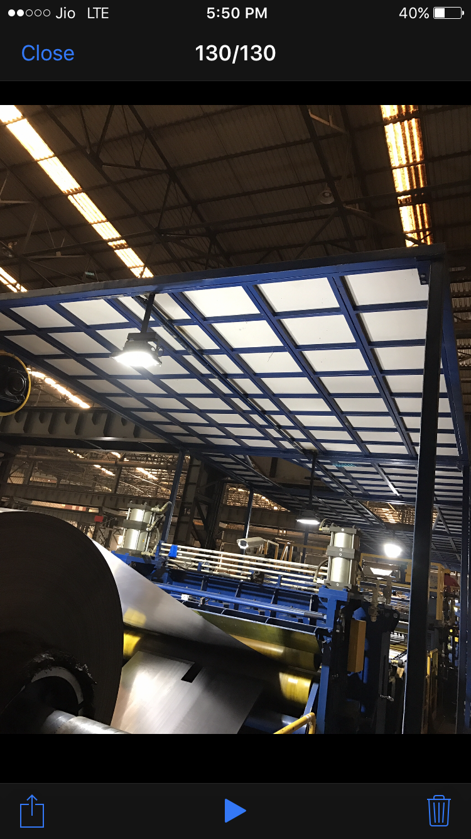
11. MACHINE SAFTEY GUARD 12. Canopy Fabrication
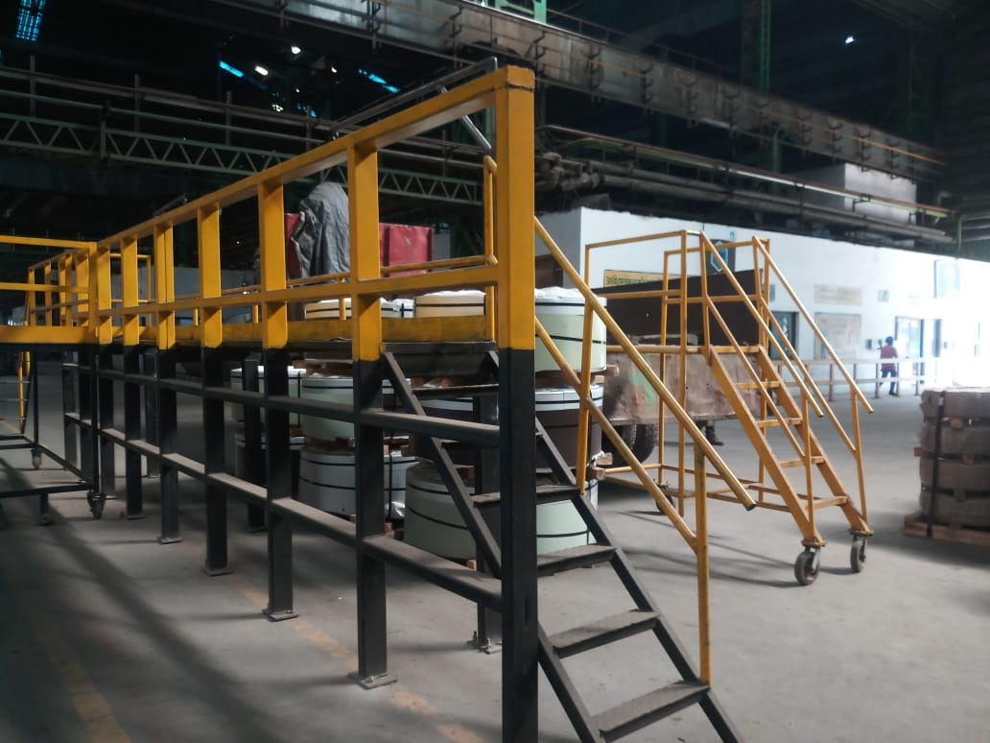
13 Truck Trampoline Supporting Railing

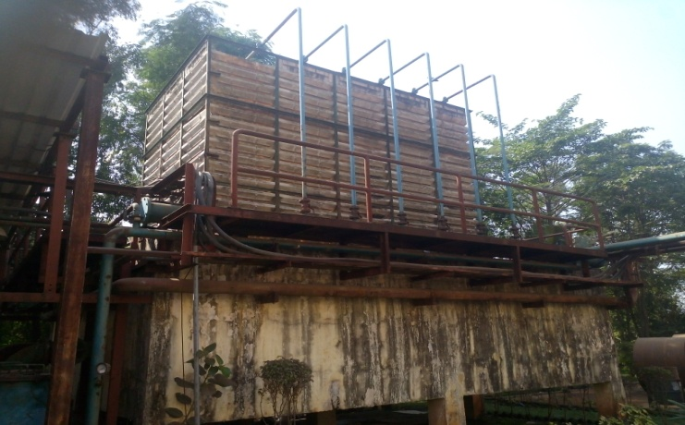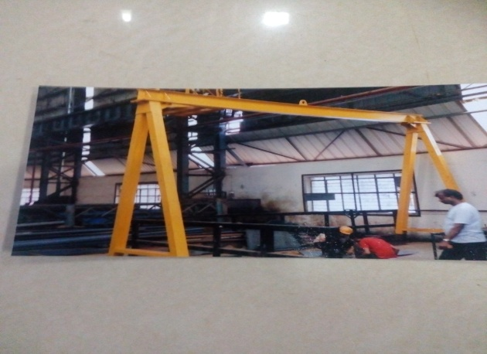
14 Cooling Tower Pipe line fabrication work 15 manually Roll Shifting Trolley-

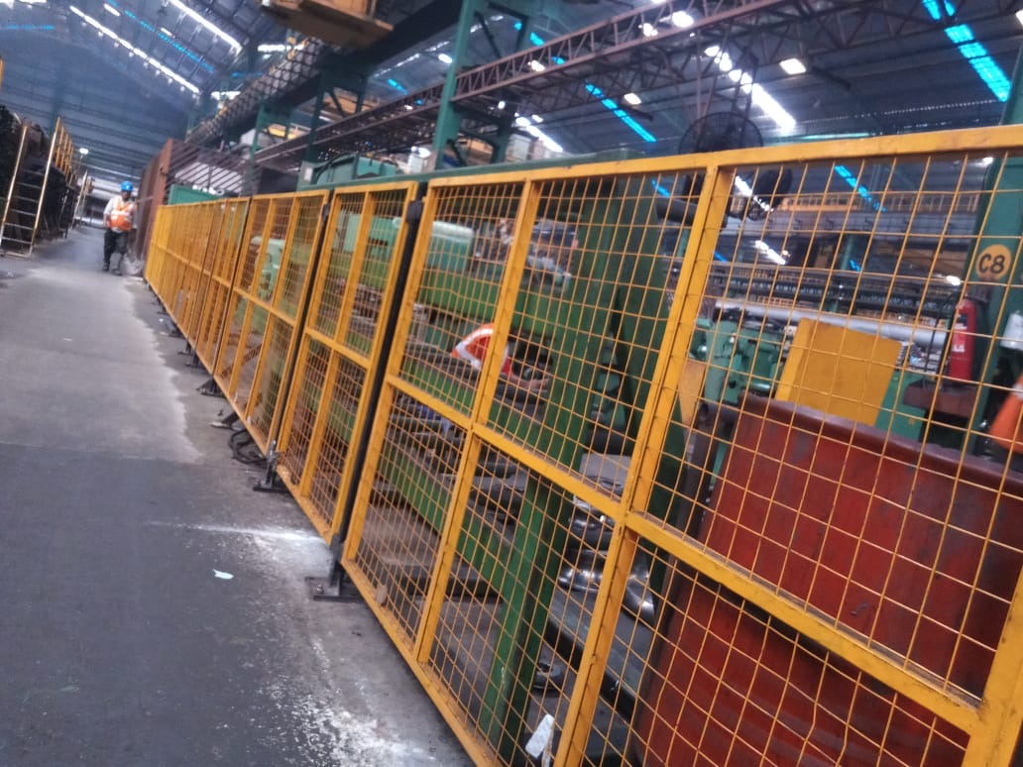
16 NO ENTRY SAFTEY MESH RAILING

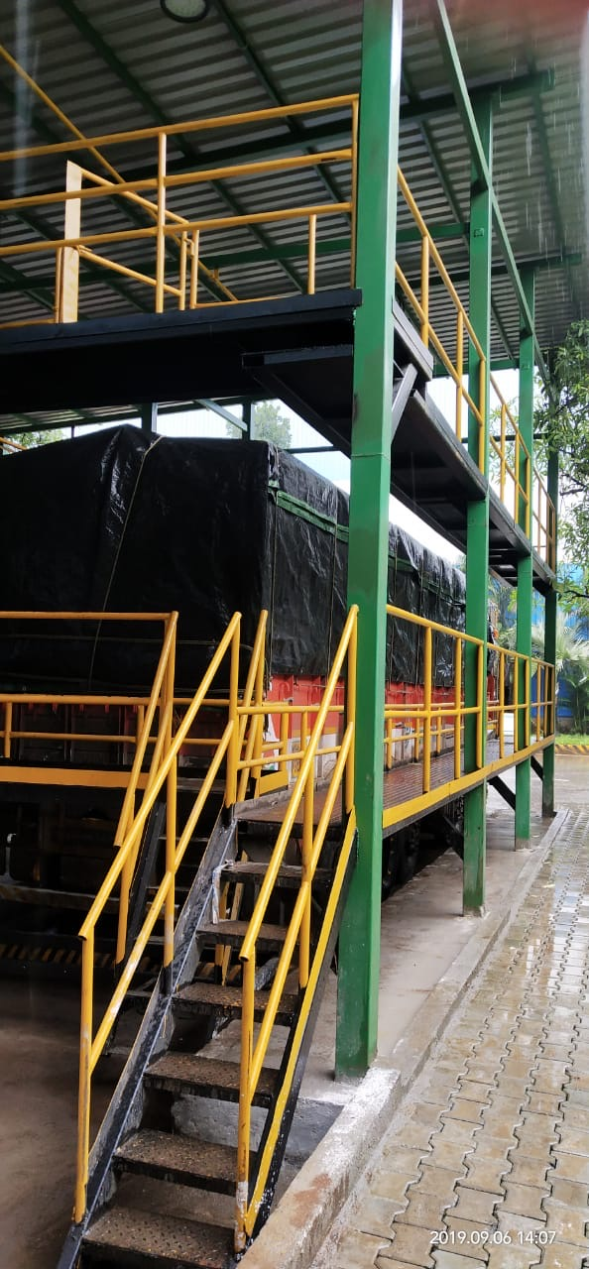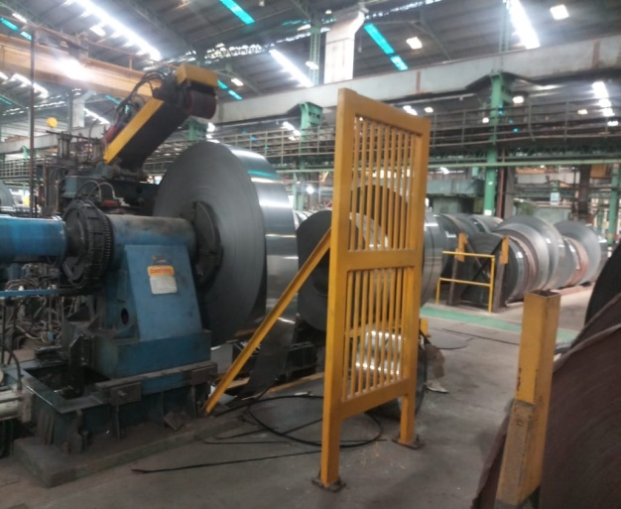
18 Truck Loading 19 CR Coil Sheet holding Safety Guard
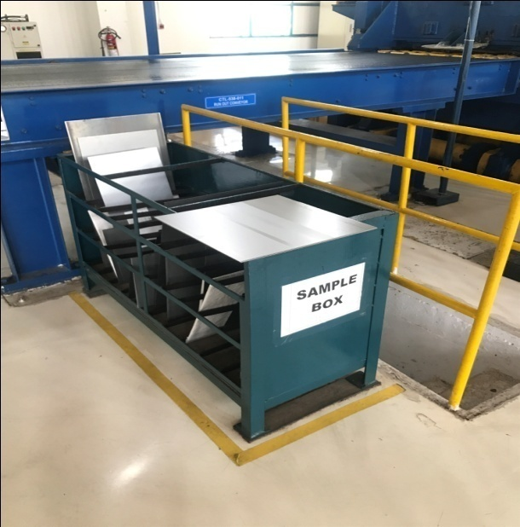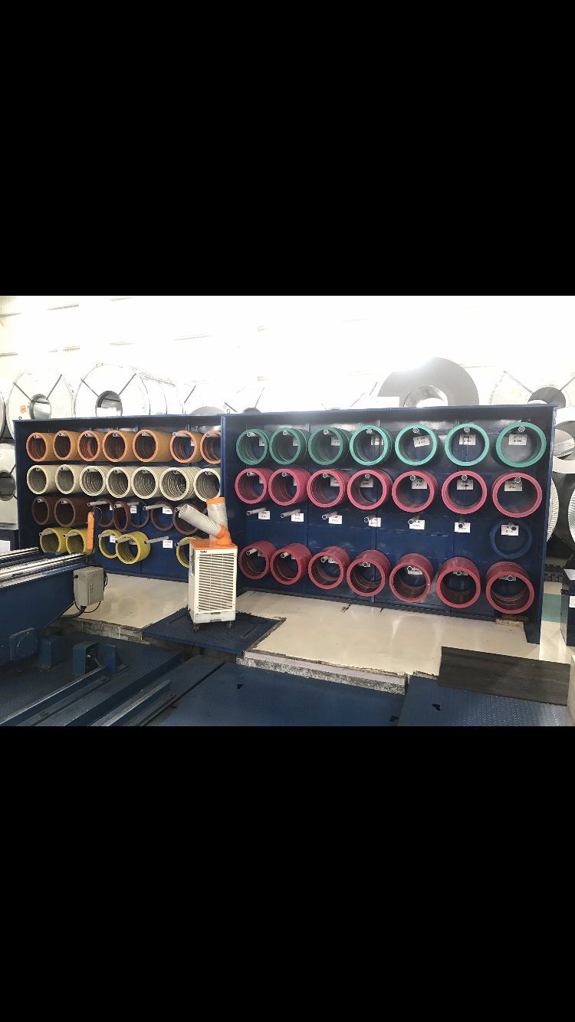
20 CR HR SAMPLE MATERIAL BOX 21 CUTTER & SPACER RACK

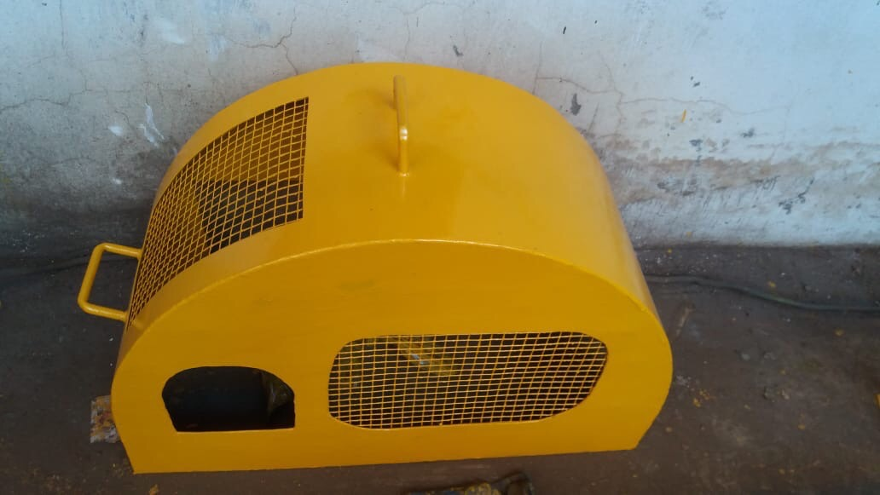
22 Machine Safety Guard
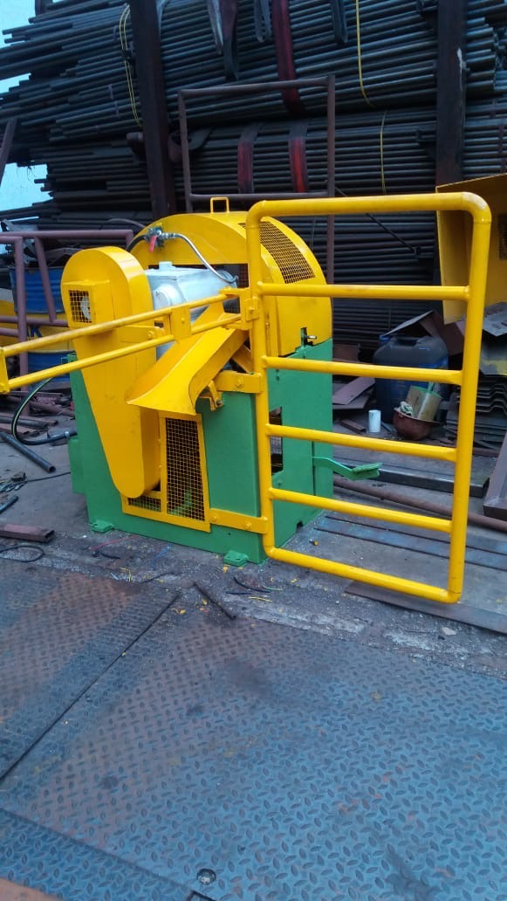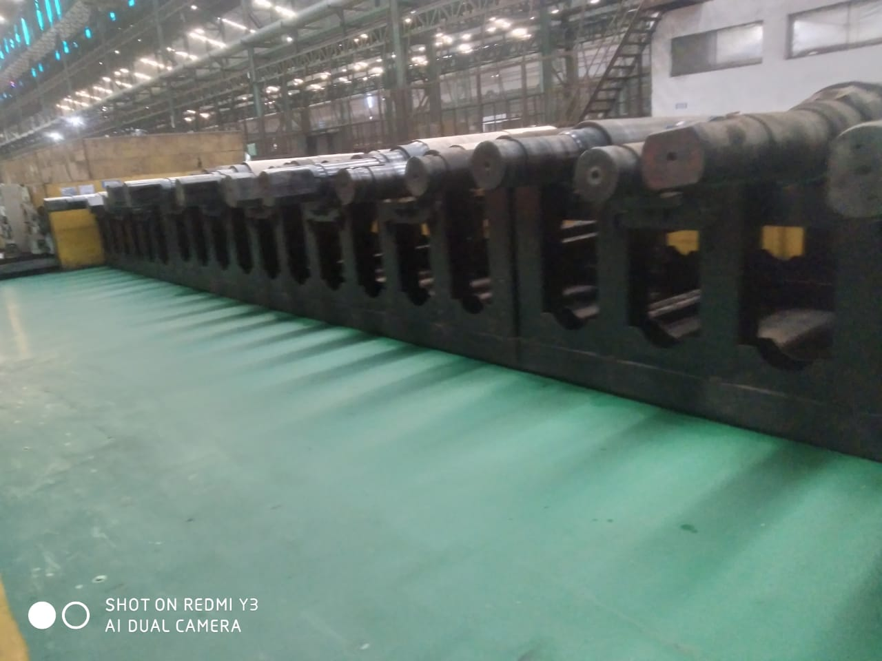
23 machine saftey Guard 24 MILL ROLL STORAGE STAND

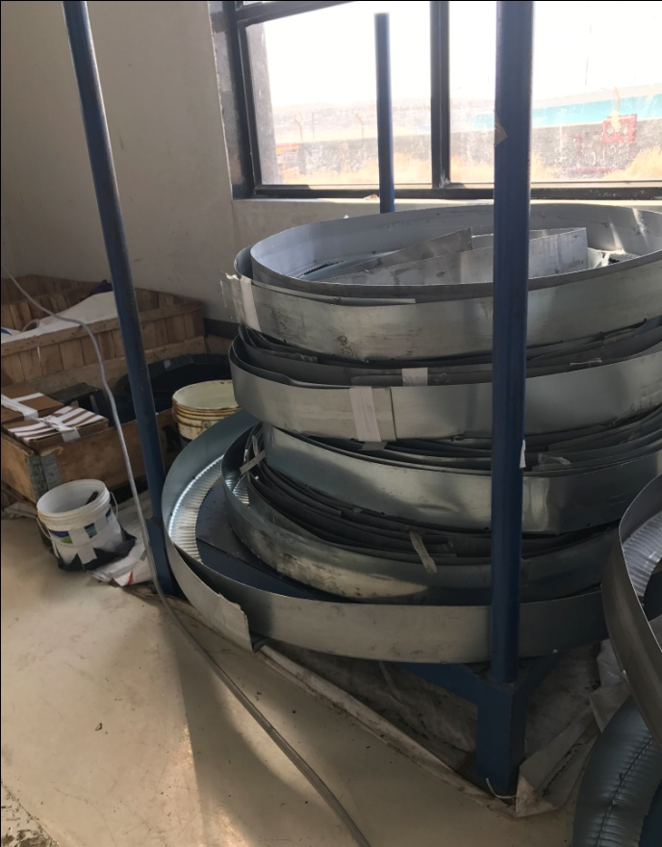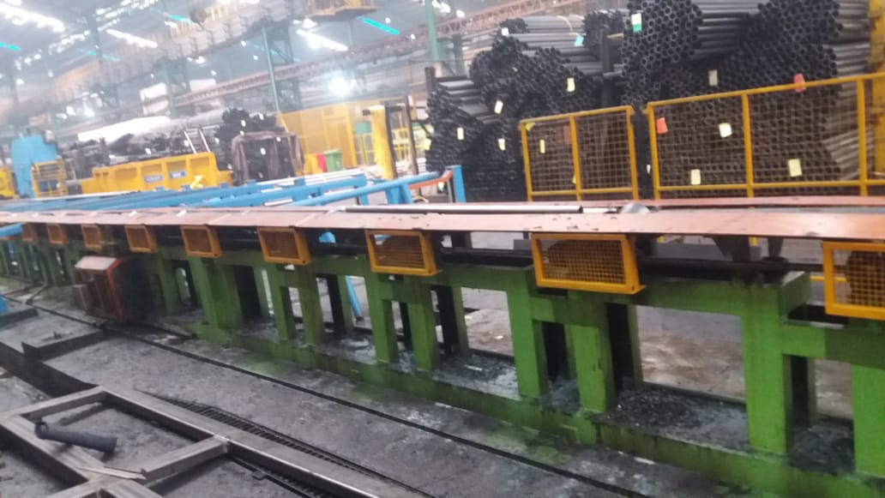
25 OD PROTECTOR STORAGE STAND 26 SAFTEY GUARD FABRICATION

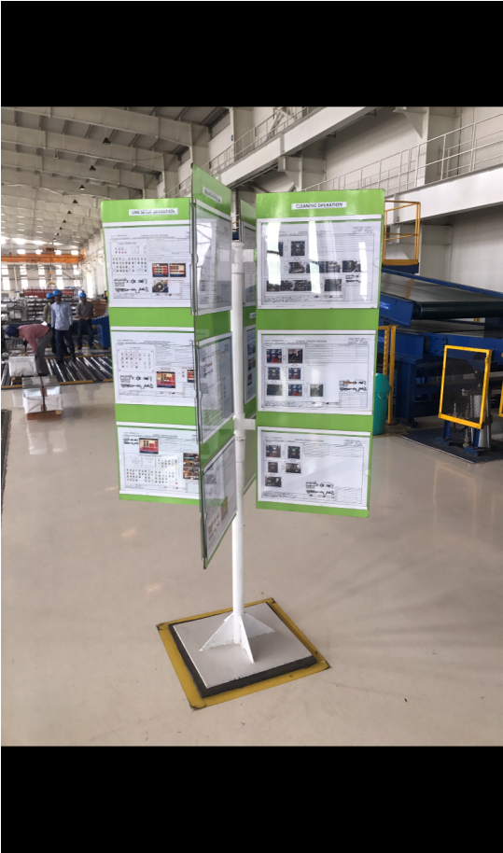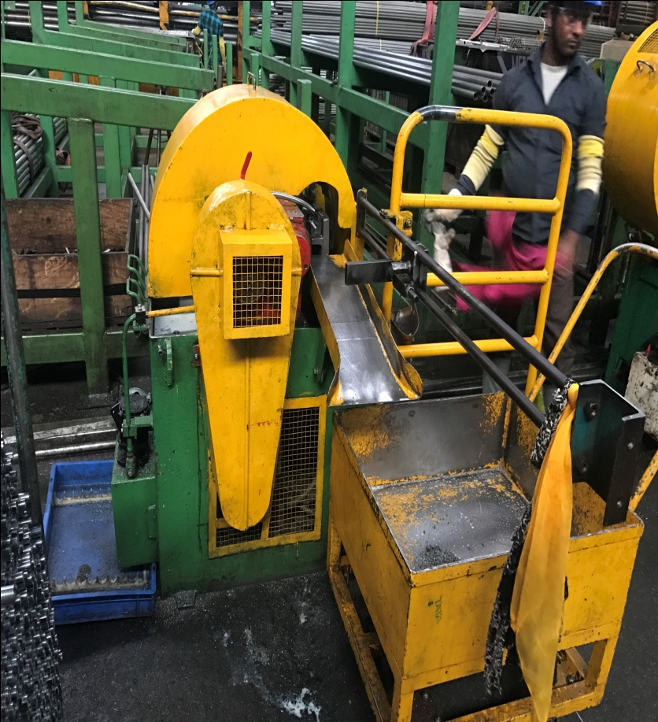
27 DISPLAY BOARD 28 CUTTING MACHINE SAFTEY GUARD

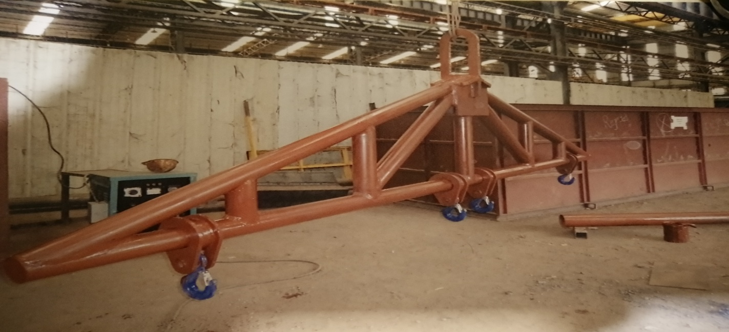
29 Pipe Bundle lifting hook
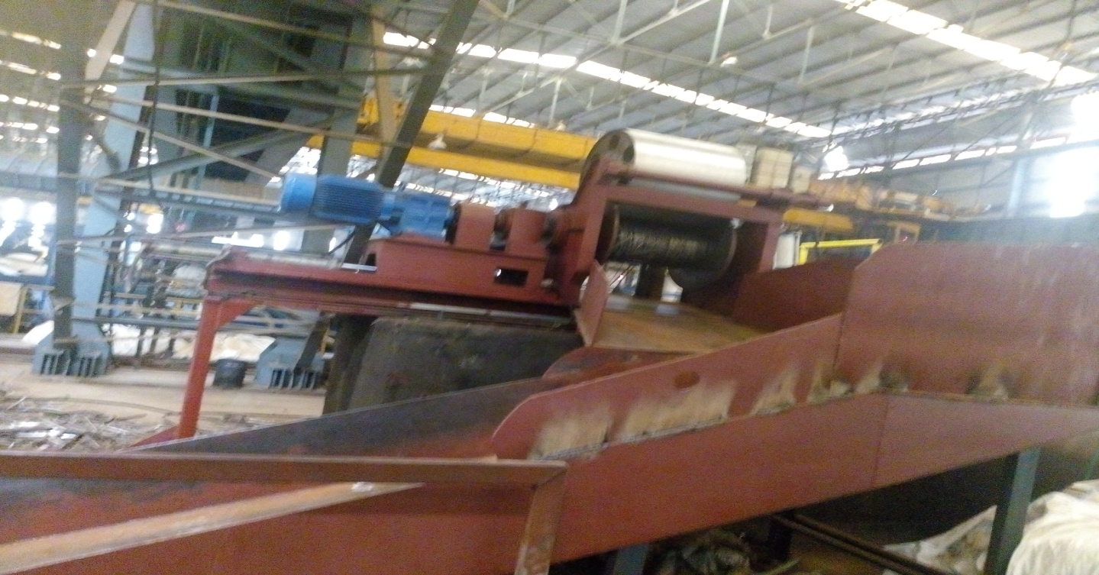
30 Scarab Binder fabrication work
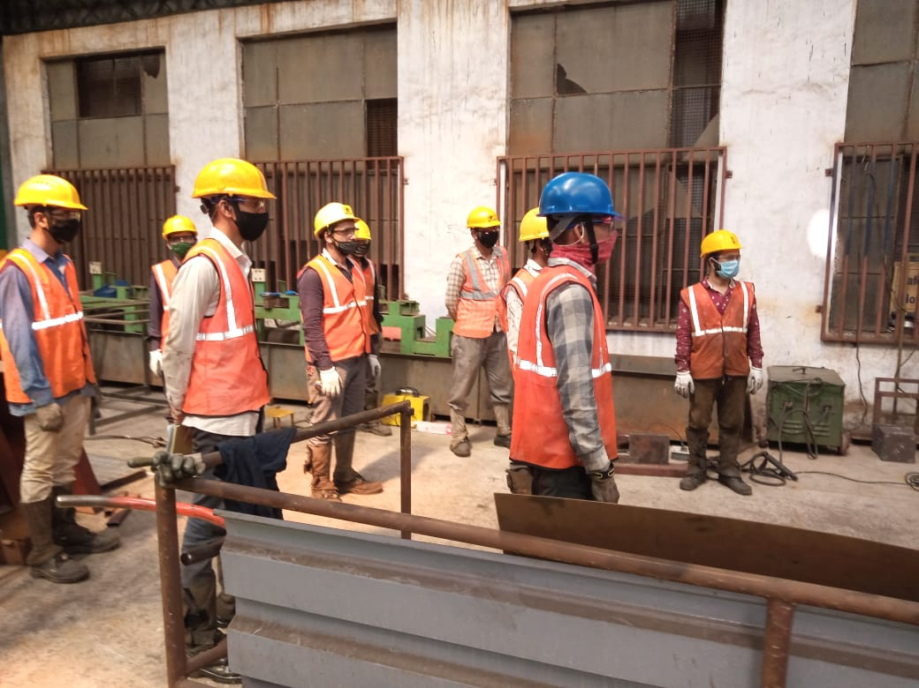
Workers meeting Before work start.
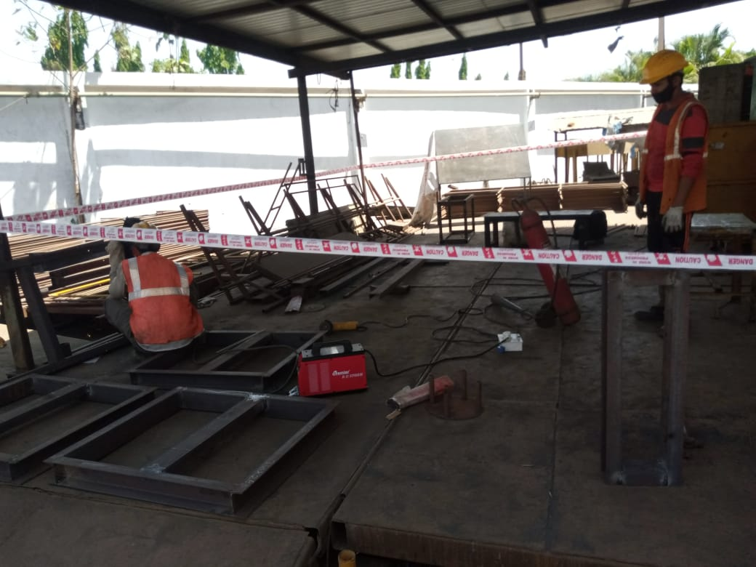
Fabrication Safety Work
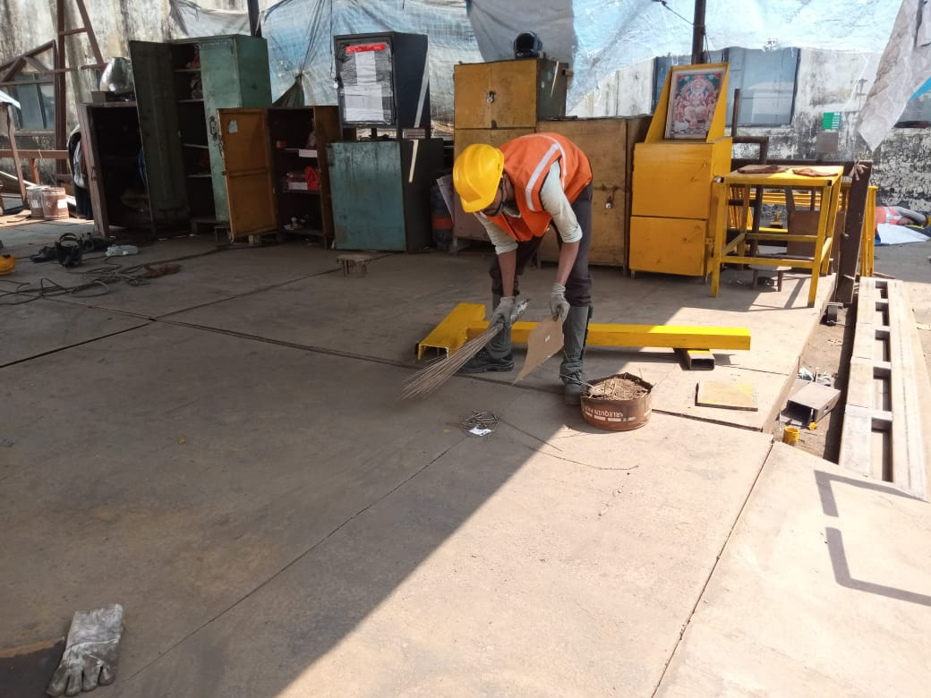
Cleaning the work area after the work done

THANK YOU

